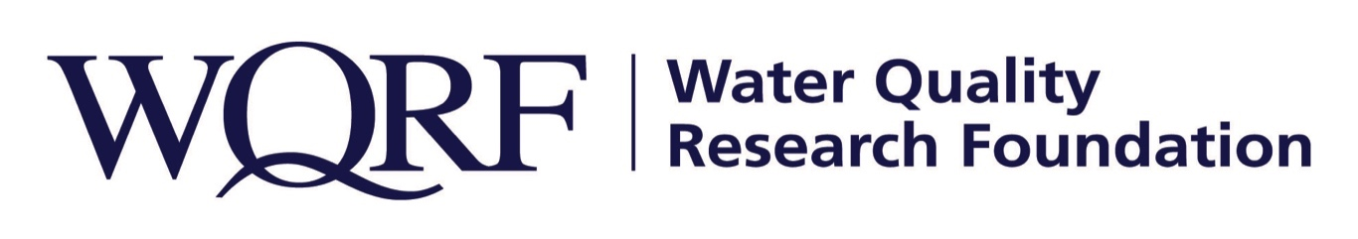

Contact: Wes Bleed
E-mail: wbleed@wqa.org
Telephone: (630) 505-1675

Kim Redden
Email: kredden@wqrf.org
Telephone: (630) 929-2512

FOR IMMEDIATE RELEASE – December 10, 2020

Water Quality Research Foundation selects research team
2020 grant project focuses on research agenda category of public awareness
LISLE, Ill. – The research agenda categories selected for the Water Quality Research Foundation’s 2020 Research Grant were regulatory affairs and public awareness. After thorough vetting by the research task force, a proposal from Dr. Kelly Reynolds of the University of Arizona was recommended and approved by the WQRF Board of Directors.
The project objective is to address public awareness by increasing knowledge, attitudes, and perceptions about POU/POE through creation of user-friendly, web-based educational materials for WQRF.org. The project will build off and supplement the public resources on WQA’s websites. The content will explain routes of exposure, potential health risks and water treatment options for drinking water contaminants.
Several communication formats will be created including both short- and long-format informational videos, infographics, archive of relevant technical articles and an interactive tool for consumers. University of Arizona and WQRF will collaborate on communication strategies to encourage utilization of the webpage by consumers and industry members.
“The project will give WQRF and our industry unique content to share with the public and confidence to discuss toxicological health effects of these contaminants,” says Mike McGowan, Chair of the research task force that will oversee the project, “this project will provide dealers with more content to share with consumers to discuss water and their health.”
The 2020 Research Grant is one of several WQRF-funded projects under way right now. Details of other WQRF research is available at wqrf.org/ongoing-studies.html.

The Water Quality Research Foundation, formerly the Water Quality Research Council (WQRC), was formed in 1952 to serve on behalf of the Water Quality Association (WQA) as a universally recognized, independent research organization. The mission of WQRF is advancing knowledge and the science of high quality, sustainable water. WQRF’s vision is water quality improvement through relevant research.

To learn more about water treatment, please visit WQA.org or BetterWaterToday.org.
Wqrf.org
# # #

