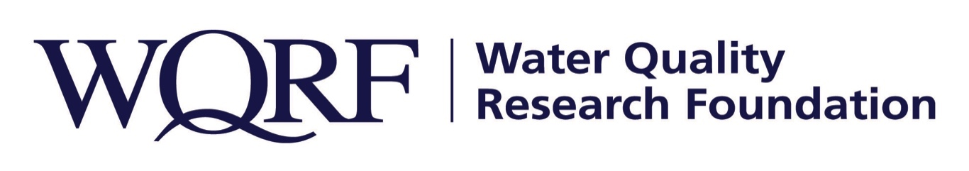
FOR IMMEDIATE RELEASE – October 18, 2019

Contact: Wes Bleed
E-mail: wbleed@wqa.org
Telephone: (630) 505-1675

New Water Quality Research Foundation-funded study aims to investigate contaminant occurrence in drinking water
Corona Environmental Consulting is conducting the research
LISLE, Ill. – Corona Environmental Consulting is conducting a state-by-state call for occurrence data regarding contaminants in drinking water for the Water Quality Research Foundation (WQRF).
The WQRF-funded Contaminant Occurrence study is led by Dr. Carleigh Samson. Samson and her team at Corona have extensive experience in developing, conducting, presenting, and publishing national drinking water contaminant occurrence studies. The research began in July 2019 and is anticipated for completion in July 2020.
“I believe this effort is a very important step for our industry,” said Gary Hatch, WQRF’s Contaminant Occurrence Task Force Chairperson. “It will help solidify that POU/POE products are a final barrier against potential contaminants in drinking water.”

The study’s main tasks:
- Conduct a state-by-state call for information in order to compile occurrence data to identify frequency, concentration, and populations affected by aesthetic contaminants, as well as occurrence of a selected list of regulated contaminants detected at levels below the enforceable MCL, but in excess of the MCLG.
- Preliminary development and design of a potential interactive tool that corresponds with occurrence data collected.

The Contaminant Occurrence study is one of several WQRF-funded projects under way right now. Details of other WQRF research is available at wqrf.org.

The Water Quality Research Foundation, formerly the Water Quality Research Council (WQRC), was formed in 1949 to serve on behalf of the Water Quality Association (WQA) as a universally recognized, independent research organization. The long-term goal of WQRF is to achieve sustained growth to conduct and fund scientific research on subjects relating to the water quality improvement industry.

WQA is a not-for-profit trade association representing the residential, commercial, and industrial water treatment industry. WQA’s education and professional certification programs have been providing industry-standardized training and credentialing since 1977. The WQA Gold Seal certification program has been certifying products that contribute to the safe consumption of water since 1959. The WQA Gold Seal program is accredited by the American National Standards Institute (ANSI) and the Standards Council of Canada (SCC).
Wqrf.org
# # #

