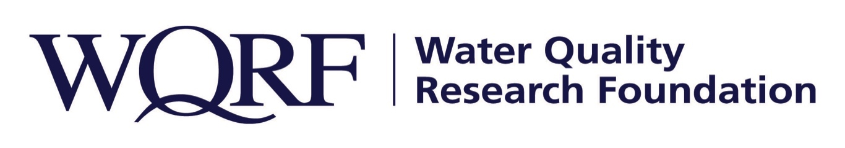
FOR IMMEDIATE RELEASE – September 17, 2020

Contact: Wes Bleed
E-mail: wbleed@wqa.org
Telephone: (630) 505-1675
WQRF-funded data collection yields contaminant map
Unprecedented amount of data now available in interactive tool
LISLE, Ill. – A new interactive online map provides a guide for consumers and water treatment specialists who want to learn more about water quality in their region. The map was developed as part of a Water Quality Research Foundation-funded data collection effort that resulted in 10 years of data and upwards of almost 60 million data points, providing very meaningful and statistically significant data for the map.
“This new tool allows consumers and water treatment specialists to learn about the historical quality of the water from public water systems in their area,” said Pauli Undesser, executive director of the Water Quality Association and the Water Quality Research Foundation. “Having this information easily accessible in an interactive tool opens up possibilities of understanding water quality across the United States in ways unimaginable until now.”
The data collection was led by Carleigh Samson, PhD, and Chad Seidel, PhD, of Corona Environmental Consulting. It began as an inquiry of regulated contaminants for concentrations below the Maximum Contaminant Levels (MCL) and above the Maximum Contaminant Level Goal (MCLG), but the project quickly was recognized as an opportunity to include data for aesthetic contaminants that cause staining, taste and odor issues (i.e. chlorine, chloramine, iron and hardness) which has long been requested by the industry.
“No other water quality data collection effort has ever resulted in this much data, as far as we’re aware,” said Eric Yeggy, WQRF Scientific Consultant and WQA Technical Affairs Director. “The online map is a quick and easy tool to visualize the data. It offers water treatment professionals guidance for handling customer calls and for treating water in specific areas of the country.”
The new interactive map was unveiled Sept. 17 at the Water Quality Association’s annual Mid-Year Leadership Conference. The Contaminant Occurrence data collection is one of several WQRF-funded projects now under way. Details of other WQRF research is available at wqrf.org.

The Water Quality Research Foundation, formerly the Water Quality Research Council (WQRC), was formed in 1952 to serve on behalf of the Water Quality Association (WQA) as a universally recognized, independent research organization. The mission of WQRF is advancing knowledge and the science of high quality, sustainable water. WQRF’s vision is water quality improvement through relevant research.

WQA is a not-for-profit trade association representing the residential, commercial, and industrial water treatment industry. WQA’s education and professional certification programs have been providing industry-standardized training and credentialing since 1977. The WQA Gold Seal certification program has been certifying products that contribute to the safe consumption of water since 1959. The WQA Gold Seal program is accredited by the American National Standards Institute (ANSI) and the Standards Council of Canada (SCC).

Wqrf.org
# # #

