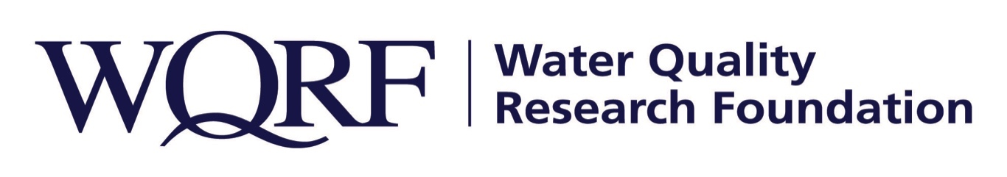

Contact: Wes Bleed
E-mail: wbleed@wqa.org
Telephone: (630) 505-1675

Kim Redden
Email: kredden@wqrf.org
Telephone: (630) 929-2512

FOR IMMEDIATE RELEASE – July 15, 2021

Second phase of predictive modeling research begins
Will use multiple data sources to help prepare for future water quality concerns
LISLE, Ill. – A study bringing together previous research efforts into a qualitative model that highlights drinking water contaminants most likely to cause violations, impact public health or generate widespread consumer attention in the next five to 10 years has been funded by the Water Quality Research Foundation. Researchers at Corona Environmental Consulting will develop the model in Phase 2 of the Predictive Modeling of U.S. Drinking Water Emergencies study.
“Our intent is the study will help prepare the industry for the future,” said WQRF Predictive Modeling Study task force chair Mike Mitchell. “In times of crisis, such as unexpected spills or contamination, public health officials and consumers turn to the POU/POE industry for help, so we’re trying to find a scientific, data-driven way to get prepared.”

Researchers Carleigh Samson, PhD, and Chad Seidel, PhD, will use data from WQRF’s Phase 1 study, water quality data collected from state regulatory agencies as a part of the WQRF-funded Contaminant Occurrence Study, and Environmental Protection Agency data including the Fourth Unregulated Contaminant Monitoring Rule (UCMR4), the Safe Drinking Water Information System, chemical data production, use and spill data from the EPA’s Chemical Data Reporting program and Toxics Release Inventory.

Each dataset will be reviewed to highlight contaminants with known or widely suspected human health impacts, broad occurrence, increasing trends in occurrence or regulatory violations over time, and likelihood to impact a large population. In addition, contaminants that are currently regulated or likely to be regulated in the future will be identified.

After the qualitative model is developed, the project team will work with WQRF subject matter experts to review existing and potential future point-of-entry and point-of-use treatment options for the highest priority contaminants likely to be needed in the future.

Phase one of this study developed a comprehensive database of drinking water crises in the last five years and their associated environmental and socioeconomic factors.

Phase two is expected to be completed by July 2022. More detail on this study and others is available at wqrf.org.

The Water Quality Research Foundation, formerly the Water Quality Research Council (WQRC), was formed in 1952 to serve on behalf of the Water Quality Association (WQA) as a universally recognized, independent research organization. The mission of WQRF is advancing knowledge and the science of high quality, sustainable water. WQRF’s vision is water quality improvement through relevant research.
WQRF.org
# # #

