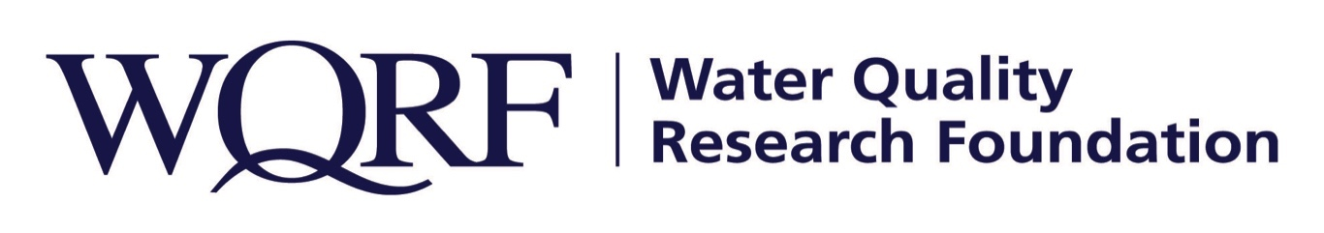

Contact: Wes Bleed
E-mail: wbleed@wqa.org
Telephone: (630) 505-1675

Kim Redden
Email: kredden@wqrf.org
Telephone: (630) 929-2512

FOR IMMEDIATE RELEASE – July 12, 2021

WQRF funds additional contaminant occurrence analyses
99 new analytes, sample location analysis could inform Contaminant Occurrence Map
LISLE, Ill. – WQRF’s Contaminant Occurrence Project will add statistical analyses for 99 more analytes and a sample location analysis for all records in the database under a project recently approved by the Water Quality Research Foundation. Carleigh Samson, PhD, and Chad Seidel, PhD, of Corona Environmental Consulting will lead the project, which builds upon their previous work that populates the WQRF Contaminant Occurrence Map.
“This work will provide more insight on the concentrations of contaminants that we didn’t get in the first phase of work, including several PFAS compounds, and grow the already robust database,” said WQRF Contaminant Occurrence Map Task Force Chair Gary Hatch of Hatch Global Consulting Services. “The project reports and interactive map offer water treatment professionals – and consumers as well – access to so much powerful information. I’m happy to see this project continue to grow.”
National statistical summaries will be provided for all 99 analytes, including several PFAS compounds, and state-by-state statistical summaries will be conducted for TOC, radon, strontium, fluoride, calcium, magnesium, glyphosate, hexavalent chromium, and 1,4-dioxane. The quality control and quality assurance work includes establishment of a consistent unit of measure for each analyte’s data records and identifying questionable data records due to non-sensical units, missing units, conflicts between below detection flags and measured results and other issues. The sample location analysis will differentiate raw water samples from finished water samples, which is of particular importance for some of the aesthetics or secondary contaminants.
The work is expected to be complete by September 2021. It is one of several WQRF-funded projects now under way. Details of other WQRF research is available at wqrf.org.

The Water Quality Research Foundation, formerly the Water Quality Research Council (WQRC), was formed in 1952 to serve on behalf of the Water Quality Association (WQA) as a universally recognized, independent research organization. The mission of WQRF is advancing knowledge and the science of high quality, sustainable water. WQRF’s vision is water quality improvement through relevant research.
WQRF.org
# # #

