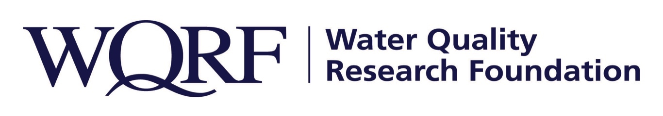
FOR IMMEDIATE RELEASE – June 27, 2019

Contact: Wes Bleed
E-mail: wbleed@wqa.org
Telephone: (630) 505-1675

Predictive Modeling study of drinking water emergencies starts July 1
WQRF-funded project also to research how water quality technology can alleviate risks
LISLE, Ill. – Two researchers from the University of Wisconsin-Milwaukee will be studying ways of determining an area’s risk for future drinking water crises and how water quality technology can alleviate those risks in a study funded by the Water Quality Research Foundation Board.
The “Predictive Modeling of U.S. Drinking Water Emergencies” study by Drs. Yin Wang and Junhong Chen will begin July 1, 2019, and is expected to run through 2020.
“We’re happy to have the opportunity to support this research,” said Dennis Rupert, WQRF President. “It will define concrete ways the industry can get better prepared to help communities reduce the risks of contaminated drinking water in the future.”

The study’s three main tasks:
- To develop a comprehensive database of drinking water crises in the last five years and their associated environmental and socioeconomic factors. Researchers also will review chemical production volume and uses in the U.S. with an emphasis on contaminants regulated by the Environmental Protection Agency.
- To assess patterns and relationships between various factors and develop a predictive model to identify key factors that pose high risks for future drinking water crises. The predictive model will be validated and refined using water crisis information collected in 2019
- To implement the improved model to evaluate approaches the water quality industry can use to alleviate the risks of future crises.

The Predictive Modeling study is one of several WQRF-funded projects under way right now. Details of other WQRF research is available at wqrf.org.

The Water Quality Research Foundation, formerly the Water Quality Research Council (WQRC), was formed in 1949 to serve on behalf of the Water Quality Association (WQA) as a universally recognized, independent research organization. The long-term goal of WQRF is to achieve sustained growth to conduct and fund scientific research on subjects relating to the water quality improvement industry.

WQA is a not-for-profit trade association representing the residential, commercial, and industrial water treatment industry. WQA’s education and professional certification programs have been providing industry-standardized training and credentialing since 1977. The WQA Gold Seal certification program has been certifying products that contribute to the safe consumption of water since 1959. The WQA Gold Seal program is accredited by the American National Standards Institute (ANSI) and the Standards Council of Canada (SCC).
Wqrf.org
# # #

