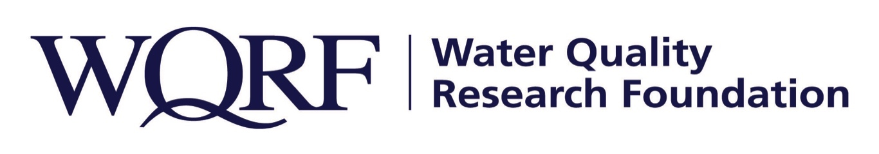
FOR IMMEDIATE RELEASE – June 18, 2019

Contact: Wes Bleed
E-mail: wbleed@wqa.org
Telephone: (630) 505-1675

Water Quality Research Foundation OKs research project concepts
Task forces will develop requests for proposals and vet the proposals
LISLE, Ill. – The Water Quality Research Foundation has approved two new research project concepts to begin request for proposal (RFP) development.
Task Forces will be recruited in the coming months for each of the two new concepts, with their first task to develop an RFP and then vet the proposals received. The RFP development and proposal vetting takes approximately six to 12 months, depending on the project’s complexity. The WQRF Board of Directors then will give final approval for the research to move forward with researcher as recommended by the task force.

The proposed projects:
- An Emerging Contaminants Consumer Study. The project would determine which emerging contaminants are already known by consumers, and to what degree the marketing of a Point of Use/Point of Entry product that is proven to reduce these contaminants will influence a purchase decision. The task force is anticipated to begin work this summer with funding approval in 2020.

- Case Studies of POU/POE use for Safe Drinking Water Act Compliance. The study would compile a list of small community systems using POU/POE systems for compliance to the SDWA, compile a database and summary report of existing case studies on use of POU/POE solutions for compliance, and publish a gap analysis of any future research needs to support the use of POU/POE treatment for compliance to SDWA. The task force is anticipated to begin work this fall with funding approval in 2020.

Open RFPs can be found on the WQRF website. Current and upcoming WQRF studies also are there for review.

The Water Quality Research Foundation, formerly the Water Quality Research Council (WQRC), was formed in 1949 to serve on behalf of the Water Quality Association (WQA) as a universally recognized, independent research organization. The long-term goal of WQRF is to achieve sustained growth to conduct and fund scientific research on subjects relating to the water quality improvement industry.

WQA is a not-for-profit trade association representing the residential, commercial, and industrial water treatment industry. WQA’s education and professional certification programs have been providing industry-standardized training and credentialing since 1977. The WQA Gold Seal certification program has been certifying products that contribute to the safe consumption of water since 1959. The WQA Gold Seal program is accredited by the American National Standards Institute (ANSI) and the Standards Council of Canada (SCC).
Wqrf.org
# # #

