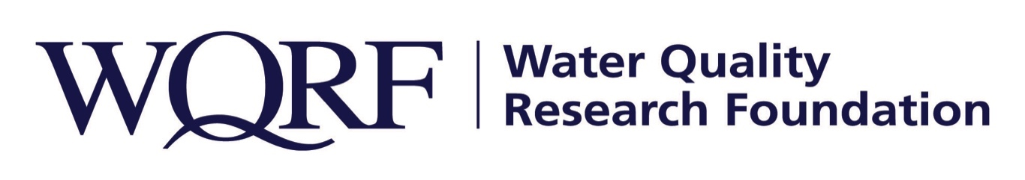
FOR IMMEDIATE RELEASE – June 14, 2019

Contact: Wes Bleed
E-mail: wbleed@wqa.org
Telephone: (630) 505-1675

WQRF-funded research demonstrates cost savings of using in-home devices to reduce health risks in drinking water
Research has been published in peer-reviewed scientific journal
LISLE, Ill. – A Water Quality Research Foundation-funded study showing the economic benefits of using point-of-use devices to reduce health risks in drinking water has been published in a peer-reviewed scientific journal.
“This is powerful data in terms of cost to society from a drinking water crisis,” said Kim Redden, WQRF Foundation Relations and Research Manager. “Having WQRF’s research validated in this way brings even more credibility to the water quality industry and the solutions it provides.”
Researchers from the University of Arizona published The Cost-benefit of POU Devices in Reduction of Health Risks from Drinking Water in the journal Environmental Research. The research found in the case study of Flint, Mich., the calculated lifetime loss to the community from drinking water lead exposure is $435 million, whereas a five-year in-home activated carbon with lead adsorption capabilities community intervention strategy would have cost $11 million. A five-year reverse osmosis intervention strategy in every household would have cost $26 million, the research showed.
The study also looked at the costs of mitigating microbiological contaminants and several other contaminants holistically, resulting in even more favorable economic benefit.
“Consideration of all contaminants listed in this study shows that POU device use in the U.S. is cost beneficial given the wide range of contaminants potentially present in drinking water,” the researchers concluded.

An executive summary of the project has been posted on the WQRF website. A two-page summary of the research also is available on WQRF’s website.

The Water Quality Research Foundation, formerly the Water Quality Research Council (WQRC), was formed in 1949 to serve on behalf of the Water Quality Association (WQA) as a universally recognized, independent research organization. The long-term goal of WQRF is to achieve sustained growth to conduct and fund scientific research on subjects relating to the water quality improvement industry.

WQA is a not-for-profit trade association representing the residential, commercial, and industrial water treatment industry. WQA’s education and professional certification programs have been providing industry-standardized training and credentialing since 1977. The WQA Gold Seal certification program has been certifying products that contribute to the safe consumption of water since 1959. The WQA Gold Seal program is accredited by the American National Standards Institute (ANSI) and the Standards Council of Canada (SCC).
Wqrf.org
# # #

