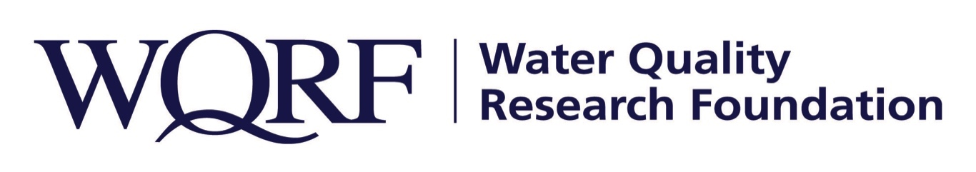

Contact: Wes Bleed
E-mail: wbleed@wqa.org
Telephone: (630) 505-1675

Kim Redden
Email: kredden@wqrf.org
Telephone: (630) 929-2512

FOR IMMEDIATE RELEASE – January 13, 2020

WQRF funds first phase of emerging contaminants research
Will study consumer awareness of emerging contaminants, health behavior motivation
LISLE, Ill. – The Water Quality Research Foundation has awarded funding for Phase 1 of an emerging contaminants research project to Dr. Marcia Silva and Dr. Sakib Mahmud of the University of Wisconsin-Milwaukee and the University of Wisconsin-Superior. The objective of phase 1 is to study consumer awareness of emerging contaminants and what messages motivate a decision to treat their water.
“To study messaging is a new area for WQRF but not uncommon in the public health field,” said Kim Redden, WQRF Foundation Relations and Research Manager. “Many researchers study how different communications methods influence health behaviors. This type of research helps the public health field decide what communication channels will be most successful for the desired health outcome – in this case, to install water treatment.”

Research objectives are:
- To understand which emerging contaminants are known by consumers, breaking them down by U.S. geographic region and demographic group
- To examine consumer awareness of Point-of-Use and Point-of-Entry water treatment and how these products can reduce the concentration of emerging contaminants
- To understand through statistical analysis what types of messaging have significant influence on a consumer’s decision to treat their water.

Phase I research is expected to begin in January 2021 and to complete by September. Researchers will conduct a comprehensive online consumer survey of 2,400 households that is representative of the U.S. population across all 50 states using stratified random sampling method to address the research questions.

Results will be reviewed, with input from state and local authorities and the American Water Works Association, to identify and prioritize the Phase 2 treatment efficacy study. Phase 2 priorities will be studying emerging contaminants of highest concern that are not being removed from treatment plants and without existing known POU/POE technology or certification standards to validate removal.

The Water Quality Research Foundation, formerly the Water Quality Research Council (WQRC), was formed in 1952 to serve on behalf of the Water Quality Association (WQA) as a universally recognized, independent research organization. The mission of WQRF is advancing knowledge and the science of high quality, sustainable water. WQRF’s vision is water quality improvement through relevant research.
Wqrf.org
# # #

