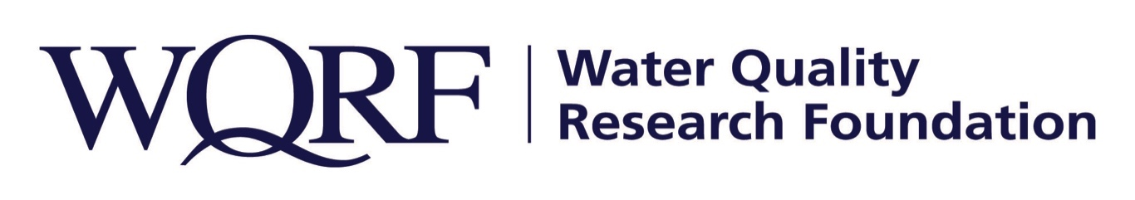
FOR IMMEDIATE RELEASE – December 7, 2018

Contact: Wes Bleed
E-mail: wbleed@wqa.org
Telephone: (630) 505-1675

Purdue researcher named 2018 Grant Award recipient
WQRF grant will fund research into efficient mitigation of emerging water contaminants

LISLE, Ill. –The Water Quality Research Foundation has named Dr. George Zhou of Purdue University the recipient of its 2018 Grant Award.

Zhou, Assistant Professor of Civil Engineering and Environmental and Ecological Engineering at the West Lafayette, Ind., university, is conducting research that will provide performance data on removal efficiencies of representative emerging contaminants and new knowledge on the effects of water quality on the performance of point-of-use systems.

“WQRF is proud to support Dr. Zhou’s research,” said WQRF Board President Ned Jones. “We expect it to help guide the water quality industry in developing cost-effective treatment devices and new ways of mitigating risks of emerging contaminants in drinking water.”

Zhou earned a Ph.D in environmental science in civil engineering, water quality microbiology from the University of Illinois. He holds Master and Bachelor of Science degrees in environmental biology from Nanjing University, and his research generally focuses on the application of biotechnologies in engineering systems.

The Water Quality Research Foundation, formerly the Water Quality Research Council (WQRC), was formed in 1949 to serve on behalf of the Water Quality Association (WQA) as a universally recognized, independent research organization. The long-term goal of WQRF is to achieve sustained growth to conduct and fund scientific research on subjects relating to the water quality improvement industry.

WQA is a not-for-profit trade association representing the residential, commercial, and industrial water treatment industry. WQA’s education and professional certification programs have been providing industry-standardized training and credentialing since 1977. The WQA Gold Seal certification program has been certifying products that contribute to the safe consumption of water since 1959. The WQA Gold Seal program is accredited by the American National Standards Institute (ANSI) and the Standards Council of Canada (SCC).
Wqrf.org
# # #

